Pictures per pages
Office Philosophy - doctor talking to a patient
Financial & Insurance - you should not put a picture on this page
Appointments - Receptionist from the team behind a desk
Parents in Dental Operatory - picture of you working on a patient

Teething – DS3_0111 – can you put the link on the drop down menu below “infant formula”
Your Child's 1st Visit – DSC_0108
Importance of Dental Health – DS3_0124 and DSC_0064F8X8
Preventing Tooth Decay – DSC_0057F8X8
Brushing and Flossing – DSC_0029F4X4 and DS3_0182web
Infant Formula – (picture of some types of Infant formula with a picture of fluoridated water) – you can get a nice jpeg of the internet with what you were thinking of putting here

Thumbsucking – get a jpeg off internet with child sucking thumb
Early Childhood Decay - picture of slight decay of teeth in a mouth

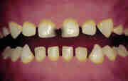 | 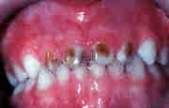 | 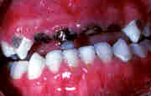
Mild Decay | Moderate Decay | Severe Decay

General Treatment – DSC-O230web
Treatment Pictures – I can add these pictures if you format it for me

Know Your Teeth - examples of Incisors, Cuspids, Premolars, Molars

